**23 Upgradation from 11g to 19c (dbua)**

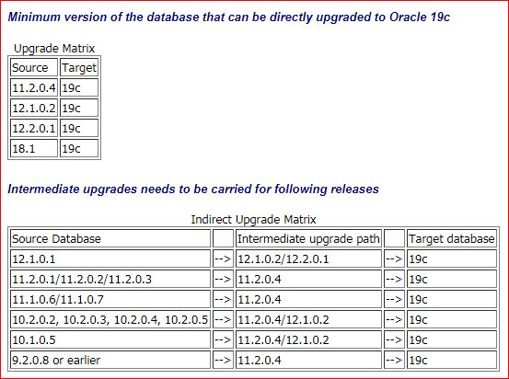

**Automatic Setup**

* If you plan to use the "oracle-database-preinstall-19c" package to perform all your prerequisite setup, issue the following command.

**#** yum install -y oracle-database-preinstall-19c

**Create the required directories**

mkdir -p /home/oracle/app/oracle/product/19c/dbhome_1

chown -R oracle:oinstall /home

chmod -R 775 /home

**PRE-UPGRADE TASKS**

1. Take the backup of the database.
2. Create guarantee restore point.
3. Check the component status.(desc dba_registey)

* Select comp_id,version,status from dba_registry;

1. Check the invalid objects.

* select count(*) from dba_objects where status='INVALID';
* if any invalid compoments and objects run ultrp.sql script(@?/rdbms/admin/utlpr.sql)

1. Install 19c software.( /SSD/oracle/app/oracle/product/19c/dbhome_1)
2. select version from v$timezone_file;
3. Empty RECYCLEBIN

SQL> PURGE DBA_RECYCLEBIN;

**Run preupgrade script**

* **/SSD/oracle/app/oracle/product/11.2.0.4/dbhome_2/jdk/bin/java -jar /SSD/oracle/app/oracle/product/19c/dbhome_1/rdbms/admin/preupgrade.jar FILE DIR /SSD/19c**
* **This script will create 3 files in the /SSD/19c location.**

1. **Preupgrade.log**
2. **Preupgrade_fixups.sql**
3. **Postupgrade_fixups.sql**

* **Preupgrade.log file will contain some recommendations like memory increase,tablespace resize,gather stats.(REQUIRED ACTIONS)**
* Once the recommended changes are done.Re-run the preupgrade script one more time and check if any other recommendations.

# **Connect to sql and run**

1. EXECUTE gather stats on DICTIONARY_STATS and FIXED_OBJECTS_STATS before upgrade.

* SQL> EXECUTE DBMS_STATS.GATHER_DICTIONARY_STATS;
* SQL> EXECUTE DBMS_STATS.GATHER_FIXED_OBJECTS_STATS;

1. Now run **Preupgrade_fixups.sql** On 11g database.

SQL> @/SSD/19c/preupgrade_fixups.sql

* **min_recovery_area_size NO Manual fixup required.**
* **parameter_min_val NO Manual fixup recommended.**
* **em_present NO Manual fixup recommended.**
* **amd_exists NO Manual fixup recommended.**
* **apex_manual_upgrade NO Manual fixup recommended.**
* **trgowner_no_admndbtrg YES None.**
* **pre_fixed_objects YES None.**
* **tablespaces_info NO Informational only.Further action is optional.**
* **exf_rul_exists NO Informational only.Further action is optional.**
* **rman_recovery_version NO Informational only.Further action is optional.**
* **The fixup scripts have been run and resolved what they can. However,**
* **there are still issues originally identified by the preupgrade that**
* **have not been remedied and are still present in the database.**
* **Depending on the severity of the specific issue, and the nature of**
* **the issue itself, that could mean that your database is not ready**
* **for upgrade. To resolve the outstanding issues, start by reviewing**
* **the preupgrade_fixups.sql and searching it for the name of**
* **the failed CHECK NAME or Preupgrade Action Number listed above.**
* **There you will find the original corresponding diagnostic message**
* **from the preupgrade which explains in more detail what still needs to be done.**
* **PL/SQL procedure successfully completed.**

**Login** to VNC and invoke **/SSD/app/oracle/product/19.0.0/dbhome_1/bin/**dbua

* ./dbua

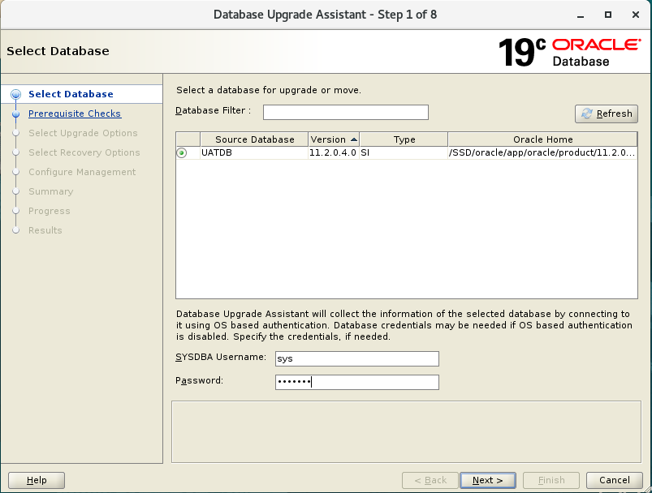

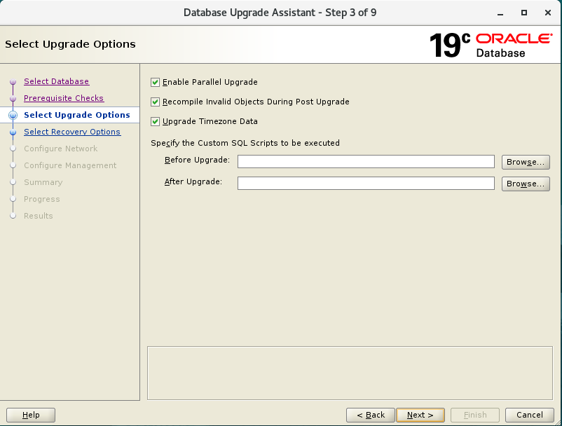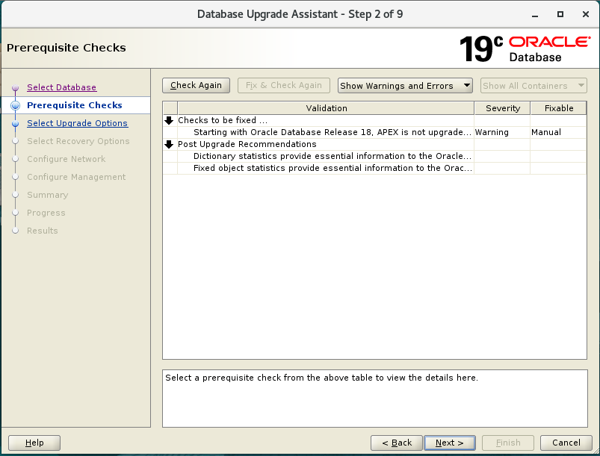

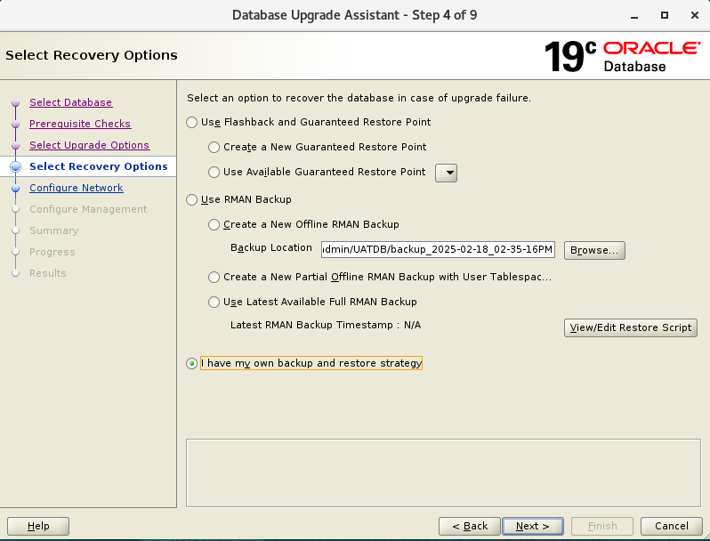

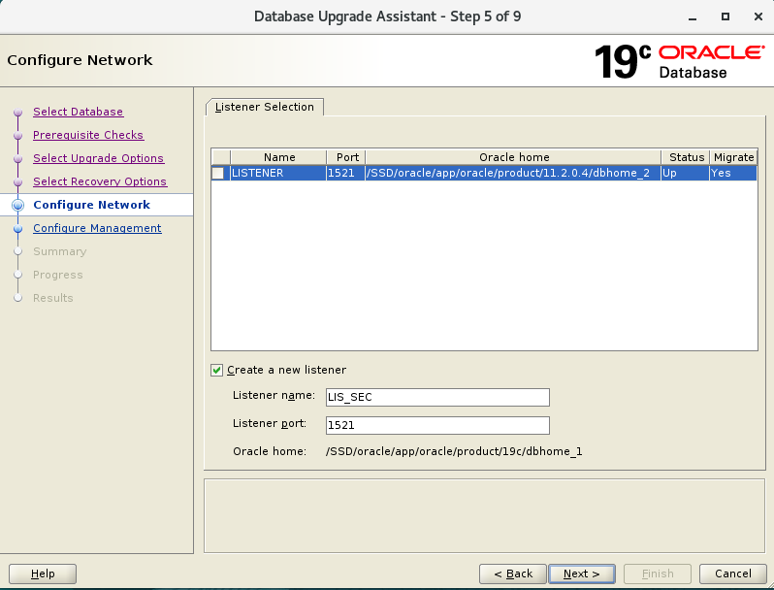

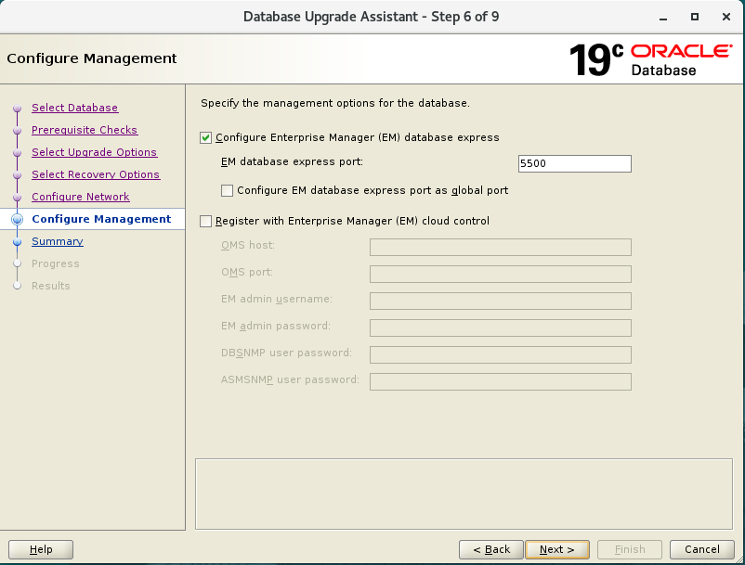

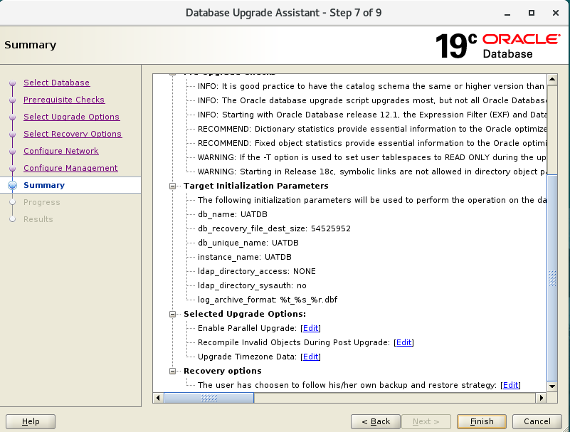

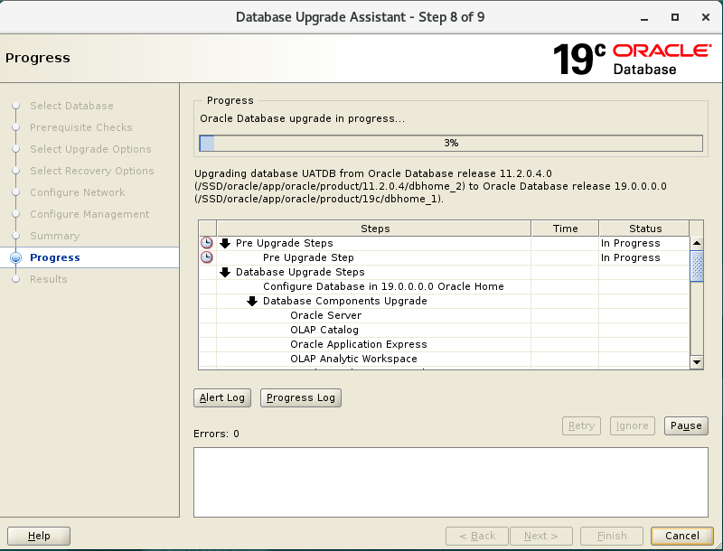

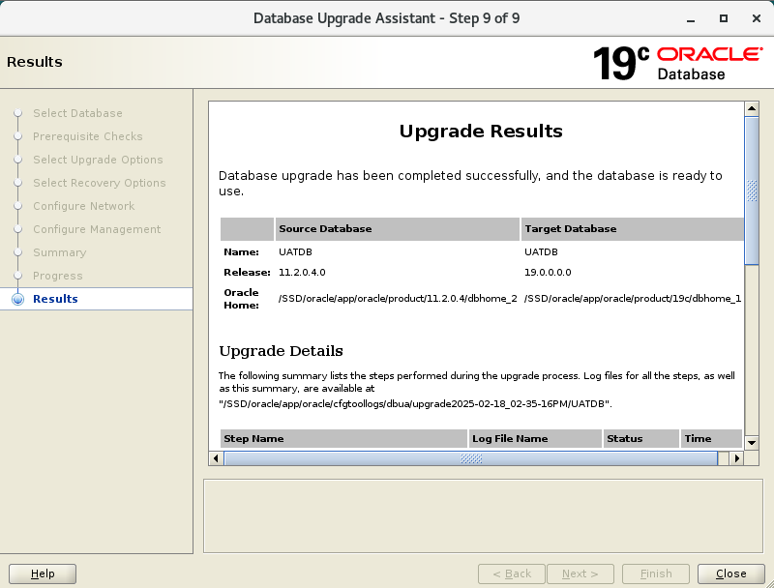

**Close the GUI and set** (. oraenv)

* Connect o sqlplus / as sysdba
* Check the version,components

SQL> select banner from v$version;

SQL>select comp_id,version,status from dba_registry;

Run postupgrade_fixups.sql

SQL>@/SSD/19c/postupgrade_fixups.sql

* Check for the invalid objects and compail.
* Select count(*) from dba_objects where status=’INVALID’;
* (@?/rdbms/admin/utlrp.sql)

**Change compatible parameter.**

SQL>show parameter compatible;

* Alter system set compatible=’19.0.0’ scope=spfile;
* Shut immediate;
* Startup;